JURY UNICA 2008
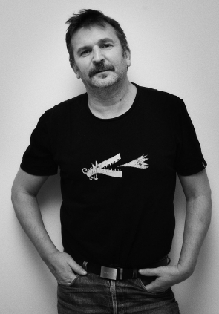Bengt Andersson (SWE)
Bengt Andersson (1955) works as a producer and a filmmaker (documentaries)
Studies at Gothenburg university, psychology and sociology and studies at Dramatiska Institutet, the Swedish university for film and television. After finishing his studies Bengt Andersson directed and edited four documentaries:
- Back at the front
- Life can change
- Sture
- ... The state of things
"Back at the front" and "Life can change" have been awarded several prices on different film festivals. "Sture" was one of 30 films in the national competition best Swedish short film 2007 at Uppsala international short film festival. The film was broadcasted
on Swedish television SVT2 in April 2008.
"... The state of things" was screened for the first time on Gothenburg international film festival 2008.
Bengt is responsible and main teacher for the two-year film education at Fridhems folkhögskola, and he was also the person who started and formed this education. Fridhems folkhögskola has been chosen to the best film school in Sweden six out of seven last years at the SFV-festival.
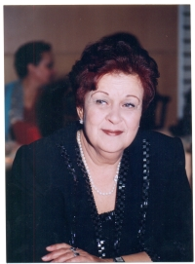Selma Baccar (TUN)
Selma Baccar was born in Tunis and is an old lover film-maker. She studied 2 years of cinematic studies with IFC. From 1969 to 1976 Selma was assistant to the direction by RTT (Tunisian TV).
Her work as a director consists of:
- in 1976, a movie regarding the Tunisian wife conditions called "FATMA 75";
- In 1985, she directed a short film "De la toison au fil d'or" and a middle film "Au pays de Tarayoun";
- than she assisted Nouri Bouzid for the direction of "L'homme de cendre";
- in february 1994,"Habiba Msika" or "La danse du feu";
- In 1996, a documentary serial with 24 episodes about profession going to be ended "Les secrets des vieux metiers";
- In 1997, 15 episodes about the wife and the power in islamic land, first time called "Princesses et Concubines, the serial will be called "Femmes dans notre memoire";
- In 2002 "Farhat Amor" a humorous serial with 30 episodes for the tunisian tv;
- In 2005 "Chaabane fi Romdhane" a serial with 15 episodes for the tunisian tv;
- In 2005 "Khochkhach" or "Fleur d'oubli" a fiction film.
Her other duties and achievements are:
- Assistant for direction. Executive producer and production manager for several short film including "La Zitouna au coeur de Tunis" directed by Hmida Ben Ammar;
- "Traversée" directed by Ben Mahmoud, "Latrace" by Nejia Ben Mabrouk and "Le solitaire" de Zembra by Othman Ben Salem.
- First women producer in Tunisia, she produced "Regard de Mouette", directed Kalthoum Bornas, and the Mohamed Ali El Okbys' movie "Les zazous de la vague", between1990 and 1992,in 1993 the Najoua Tlilis' short film "Heritage"
- In 1999 , producer manager a humorous serial for the Tunisian TV.
- In 2000, executive manager Abdellatif Ben Ammars' movie "NORIA" and executive producer Ezzedine Harbaouis' soap opera "RIH EL MISK 2" with 15 episodes.

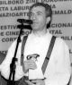Hassan Dezvareh, Iran
Hassan Dezvareh was born in 1947 and studied Mass Media and Communication and Art in Germany.
After graduating, he worked as an art journalist and teacher at a college in Germany.
In the early 90s he studied film in Los Angeles.
He is currently teaching cinema and photojournalism at the Art University in Tehran and is also responsible for the international relations at the Iranian Young Cinema Society and Tehran International Short Film Festival.
He has been a jury member at the following professional short film festivals around Europe:
- Tampere, International Short Film Festival, Finland
- Winterthur, International short film festival, Switzerland
- Festival of Nations, International short film festival, Austria
- Dakino, International short film festival, Romania
- Message to man, International short & documentary film festival, St. Petersburg /Russia
- Drama, International short film festival, Greece
- Odense, International short film festival, Denmark
- Bilbao, International short and documentary film festival, Spain
Hassan has also been a jury member at several domestic short film festivals.

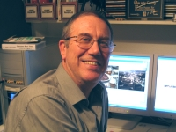Michael Gough FACI(M) (GBR)
Michael is a successful film and video maker who started filming on Super 8mm. in 1967.
His productions include fiction, animation, newsreel and travel documentaries which have won many major awards including the Movie Maker Ten Best Competition and the IAC British International Amateur Film Festival.
His skill awards include those for sound, photography, commentaries and editing. He wrote a series of articles for beginners in a national magazine and presented a series of local radio programmes on amateur movie making. He is now a keen exponent of non-linear computer editing.
Michael is in high demand as a speaker and a judge at all levels. He was made a Master Movie Maker Fellow of the IAC in 2007. He has just retired as Chairman of Newcastle ACA Film and Video Makers and is a National Council Member of the IAC. Throughout all this he has had the wonderful support of his wife, Linda, who is the Chairman of the IAC.

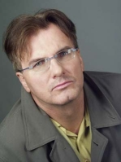Paweł Łęski (POL)
Paweł Łęski completed the National Theatre Academy in Warsaw (acting), and graduate journalism studies at the University of Warsaw, studies at ESEC in Paris (directing).
He has played in a few dozen plays in Poland and several dozen films and television series, among them; "Le Grand Mome" - a series for the French television channel TF1, the main role. Role of Smolensky in the American television miniseries "Cain and Abel", the role of Pierre in the long-running Polish television series, "Klan", as well as the role of Wiktor in Polish television series, "Sprawa na Dziś."
He has made several documentaries for Polish television, including, "Burza mózgów", "Język filmu" and "Próba." He has directed the play "Merlin Mongoł."
He has also written two books: "Zabić Prezydenta" and "Szelest Warg." He is frequently a member of the jury for international amateur film festivals. He established the first private acting school in Poland (1991-2000).

Kees Tervoort (NLD)
Kees Tervoort (1949) was born in Velsen, North West Netherlands
He became a member of Videofilmers Velsen in 1984, when his wife was asked to play the lead part in a production of the Velsen club and he has been making films (preferably feature films) with much pleasure ever since. He has taken part in many national and international festivals, won several prizes and five times had the honour of participating in UNICA with a film.
Via NOVA (Netherlands Organisation of Audio-visual Non-professionals) he took part in a film judging course, he is a regular member of the ‘travelling judging panel’ in the NOVA-district North-Holland and has judged at many national and international festivals. He has a preference for feature films and, in judging these, he pays particular attention to the theme of these films.

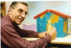Jef Van Gompel (BEL)
Jef Van Gompel is retired speech- and voice-therapist.
Since 1968 active as filmmaker, scenario writer and editor of the Brugean Club magazine : Filmkrant. For 14 years he was board member and president of the club : Koninklijke Brugse Amateurcineasten.
He realised 97 short films, of which 28 feature films, 38 documentaries and 31 animated films. Nine times one of his films was shown in the Belgian UNICA Program. He conducted training courses for candidate jury members and took the lead of Workshops for animation film makers.
Since 1977 he was on a regular basis member of the jury at several film festivals in Belgium, Holland, Germany and Austria. He was jury member at UNICA 1994 Hradec Kralove, 1998 Mayerhofen, 2001 Tallinn and 2003 Warsaw.
Jef was secretary of the organizing committee at UNICA 2005 Blankenberge. In 2007 he received the UNICA Medal for Special Merit from the Belgian Film Federation : Centrum voor Beeldexpressie.

